# Reaction Time Game

Using JavaScript, CSS and HTML build a small interactive 2D game. The rules of the game are as follows:

1. The game starts with 3x3 layout of white boxes
2. When user presses “Play”, one box turns black randomly
3. User must click the black box within a time limit, say 2 seconds
4. Then another box turns black and so on. 10 successful clicks to advance to the next level.
5. With each level increases difficulty:

* More boxes (e.g., 4x4, 5x5)
* Shorter reaction time (decrease by half/configurable multiplier)
* More clicks required to advance (configurable)

1. Score is measured by how many black boxes user was able to click throughout the game

You can refer to the below mocks to get an idea of how it should look, but don’t stop it from being innovative. Also, you need to make it responsive, users should be able to play it in mobile browsers as well.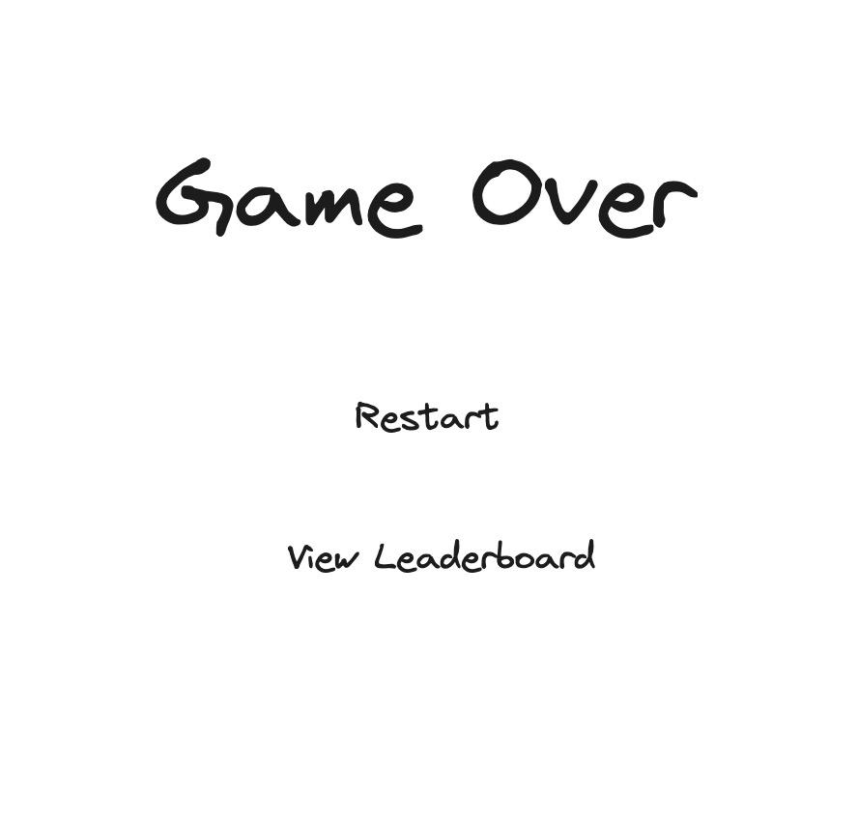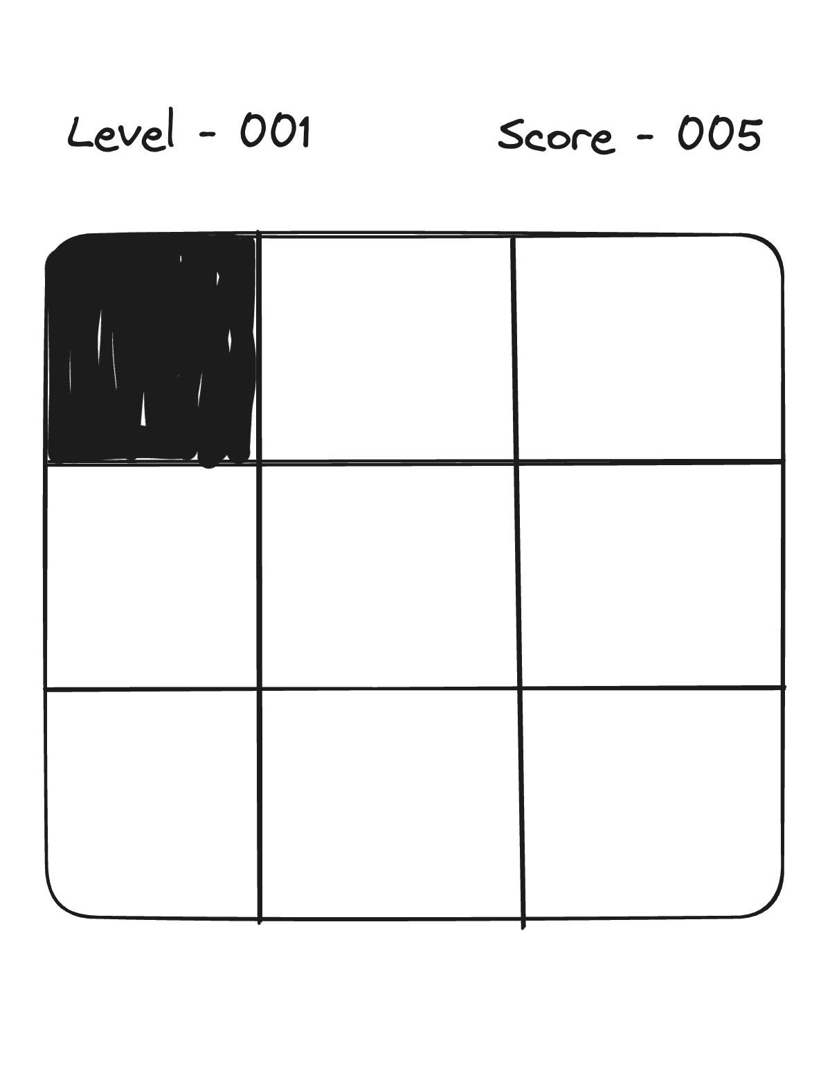

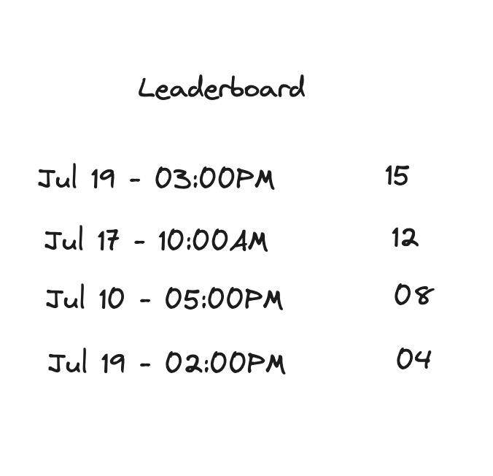

What will you learn from this exercise:

1. DOM manipulation
2. Event handling
3. Timers
4. Game logic
5. CSS & Responsive design
6. Local storage

## Extension - 2 player mode

2 players can join a game session. Upon start, they can see each other’s mouse movements and clicks